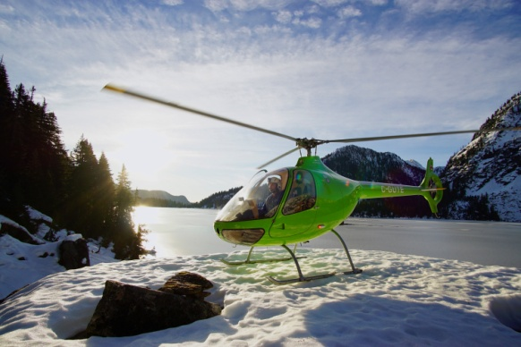

First Flight: January 2018
External Finish: Sublime Green
Internal Finish: Beige Leather
Mainly used: Flight Training

Miscellaneous
Flight Controls: | Adjustable Copilot Pedals
Fire Extinguisher: | Fire extinguisher leather pouch
 | Fire Extinguisher
Landing Light: | LED Landing Light
iPad Holder: | Flypad Pilot (incl. power supply)
Sling Hook: | Complete Installation
Headsets: | Bose A20 Bluetooth
Avionics & Instrument Panel
EFIS: | Aspen Avionics EFD1000 Primary Flight Display System
Altimeter: | Dual Barometric Altimeter (hPa and Hg inches)
Transponder: | Garmin GTX 335 – Mode S
VHF + VOR + GPS: | Garmin GTN 650
Intercom: | PS Engineering PM 1000
VOR Antenna: | VOR Antenna alone
ELT: | KANNAD 406 Integra Installation
Compass: | Northern Hemisphere

